EPAG LITERACY / NUMERACY STRENGTHENING SUPPORT SERVICES

TRAINEE LITERACY
ASSESSMENT TOOL

EPAG

N ational
A dult
E ducation
A ssociation
L iberia



OVERALL OBJECTIVE OF THIS TOOL:

- To enable EPAG trainers how to administer the literacy assessment with their trainees.

INTRODUCTION:

During Round One of the EPAG training, literacy levels varied widely in the classrooms and even girls with strong verbal skills often lacked good writing skills. EPAG Round Two will include an even greater mix of literacy levels!

As part of the literacy / numeracy strengthening activities for EPAG service providers during Round Two, assessing the literacy level of trainees in each classroom is one of NAEAL’s first activities. Based on the inputs from the service providers, NAEAL has developed this training tool to be used to train trainers to assess the literacy levels of their EPAG trainees. NAEAL has adapted materials from NAEAL and CESLY to create this tool. EPAG has three generalized literacy / numeracy levels:
LEVEL A
LEVEL B
LEVEL C
Level A = Basic
~1st – 3rd grade level
Needs pronunciation practice, reading and writing practice, arithmetic practice, etc.

Level B = Intermediate
~ 4th – 6th grade level
Needs reading practice, jobs and business vocabulary, accounting practice using money, how to use a cellphone calculator, etc.

Level C = Proficient
~ 7th grade and above
Needs spelling practice, technical exercises tailored for business such as record-keeping, technical exercises tailored for jobs such as employment exams, writing a customer’s bill, etc.

Due to the widely varying quality of education in Liberia, these are very generalized literacy / numeracy levels. (In Liberia, you can be a high school graduate and still have trouble reading and writing.) Also note that in most cases, each girl is expected to have matching literacy and numeracy levels.

USING THE ASSESSMENT TOOL:

Dear EPAG trainers:
This is the tool for you to assess the literacy and numeracy levels of the girls in your classes. There are two different versions of the tool. Please follow the instructions below as you use this tool.

- Introduce the assessment to your class
- Starting in early August 2011, you will use the assessment tool in all your classrooms. On the day you will be conducting the assessment, put aside one-hour of class time and make sure you have enough copies of the assessment prepared.
- Encourage the girls to do the best they can answering the questions. Explain to them that this assessment will help you know how to best teach them.
- Reassure them that this is not a test and they will not be penalized for wrong answers or blank answers.
- Answer any questions the girls have about the assessment.

- Lay the following ground rules
- Work with the girls to put up a list of ground rules for taking the assessment.
- Tell them that there are different versions of the assessment, so they cannot look at their neighbors paper for answers.
- No one is allowed to use calculators.
- Stress the instructions: writing sentences, showing work, etc.

- Administer the assessment
- Hand out the assessment versions randomly, so they are mixed-up.
- Tell the girls they have 45-minutes to complete the assessment.
- Monitor the girls to ensure they do not cheat.
- As the girls are taking the assessment, walk around the room and make sure they are following instructions: writing as much as possible, showing their work, etc.

- Score the assessment
- Collect all the assessment sheets. (See instructions on the next page.)
- After session, score the sheets according to the instructions and answer key provided by NAEAL.

- Report back to NAEAL
- Together with the service provider, report back to NAEAL to review the scoring and categorize the learners into levels A, B, and C.

HOW TO SCORE THE ASSESSMENT:

LITERACY SECTION
When scoring the literacy questions, pay attention to spelling, writing, punctuation, use of lowercase and uppercase letters, sentence structure. Award full or partial points on a consistent basis.

The literacy section has 10 questions in four parts:

Questions 1-3: Name the picture
Each of the 3 questions has a total possible value of 5 points = 15 points

Questions 4-6: Simple story comprehension
Each of the 3 questions has a total possible value of 5 points = 15 points

Question 7: What do you see story writing exercise
One question has the total possible value of 40 points = 40 points

Question 8-10: Advanced story comprehension
Each of the 3 questions has a total possible value of 10 points = 30 points

TOTAL POSSIBLE = 100

NUMERACY SECTION
When scoring the numeracy questions, pay attention to correct answers as well as the work demonstrated to reach the answer. Award full or partial points on a consistent basis.

The numeracy section has 10 questions in two parts:

Questions 11-18: Simple & advanced arithmetic
Each of the 8 questions has a total possible value of 10 points = 80 points

Questions 19-20: Real life math problems
Each of the 2 questions has a total possible value of 10 points = 20 points

TOTAL POSSIBLE = 100

LITERACY | 1: Max 5 |  | Full points means correctly spelled.
LITERACY | 2: Max 5 |  | Full points means correctly spelled.
LITERACY | 3: Max 5 |  | Full points means correctly spelled.
LITERACY | 4: Max 5 |  | Full points means a correct sentence.
LITERACY | 5: Max 5 |  | Full points means a correct sentence.
LITERACY | 6: Max 5 |  | Full points means a correct sentence.
LITERACY | 7: Max 40 |  | Full points means a correct paragraph citing at least four things.
LITERACY | 8: Max 10 |  | Full points means sentence(s) which correctly respond to the question.
LITERACY | 9: Max 10 |  | Full points means sentence(s) which correctly respond to the question.
LITERACY | 10: Max 10 |  | Full points means sentence(s) which correctly respond to the question.
LITERACY | TOTAL  Out of 100

SCORING STEPS:

- Fill in the scores in the grids on the left. Follow the instructions.

- Find the total score for literacy (out of 100 possible points).

- Find the total score for numeracy (out of 100 possible points).

- Take the 2 figures and divide by 2. For example

Literacy = 85
Numeracy = 75
=160

Divided by 2 = 80

- Rank to trainees into levels A, B, or C, as follows:

A = 0 - 69

B = 70 - 85

C = 86 - 100

NUMERACY | 11: Max 10 |  | Full points means correct answer.
NUMERACY | 12: Max 10 |  | Full points means correct answer and shows work.
NUMERACY | 13: Max 10 |  | Full points means correct answer.
NUMERACY | 14: Max 10 |  | Full points means correct answer and shows work.
NUMERACY | 15: Max 10 |  | Full points means correct answer.
NUMERACY | 16: Max 10 |  | Full points means correct answer and shows work.
NUMERACY | 17: Max 10 |  | Full points means correct answer.
NUMERACY | 18: Max 10 |  | Full points means correct answer and shows work.
NUMERACY | 19: Max 10 |  | Full points means correct answer and shows work.
NUMERACY | 20: Max 10 |  | Full points means correct answer and shows work.
NUMERACY | TOTAL  Out of 100
NAME:
COMMUNITY:
CLASS:
TRAINER

Name the picture. Write each answer in the box.



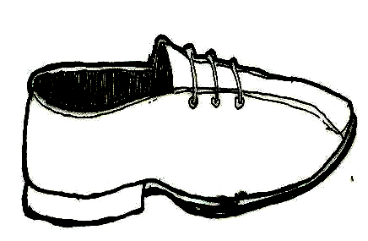

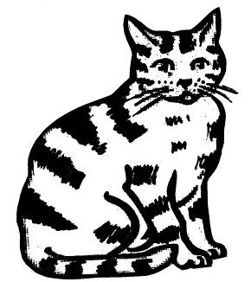

Read the story and answer the questions.
Try to write sentences if you can.

STORY:

Bendu’s mother is a farmer.

Bendu helped her mother make a big farm last year.

They planted rice, cassava, pepper, and beans.

QUESTIONS:

- What is Bendu’s mother’s work?

____________________________________________________

- Name one of the foods they planted on the farm.

____________________________________________________

- When did they make the farm?

____________________________________________________

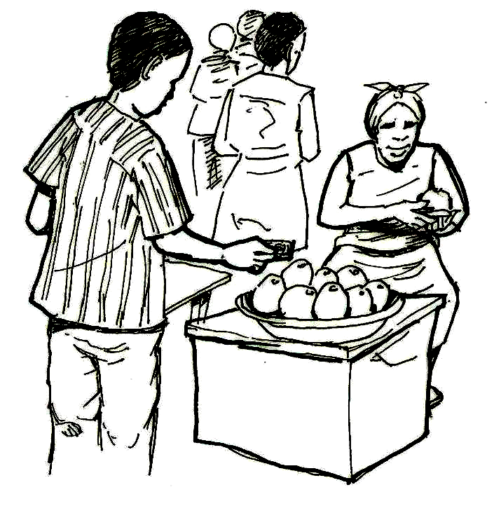
What do you see happening in this picture?
Describe at least 4 things in paragraph format.
Write your answers below:

_________________________________________________________________________

_________________________________________________________________________

_________________________________________________________________________

_________________________________________________________________________

_________________________________________________________________________

_________________________________________________________________________
Read the story and answer the questions.
Try to write sentences if you can.

“Comfort’s New Job”

Comfort completed her training program and never missed a session.

Today she is talking to her friend. She is feeling very happy. She is starting her new job tomorrow. She is mending her skirt. She is shining her shoes. She is thinking about her first day of work.

Comfort plans to wake up soon tomorrow morning to get ready. She will make sure she arrives early to her first day on the job.

QUESTIONS:

- Why is Comfort happy?

______________________________________________________________

______________________________________________________________

- What did Comfort do to get ready for her job?

______________________________________________________________

______________________________________________________________

- What advice would you give Comfort to help her start her job?

______________________________________________________________

______________________________________________________________
Answer the math questions below.
Please show how you got your answers.
SHOW YOUR WORK!

ADDITION

11. 12.
1 5 2 4
+ 1 0 + 4 9

SUBTRACTION

13. 14.
7 4 8 4
- 2 3 - 3 7

MULTIPLICATION

15. 16.
1 4 2 4
X 2 X 3

DIVISION

17. 18.

5 30 4 17
Answer the questions below.
Please show how you got your answers.
SHOW YOUR WORK!

19.
Write the value of the money you see in the box. Show your work!

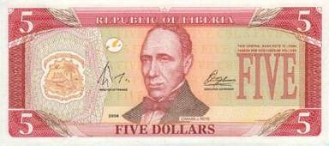


20.
Kadiatu bought 3 bottles of palm oil for $60LD each.

How much money did Kadiatu spend for the 3 bottles of oil?

NAME:
COMMUNITY:
CLASS:
TRAINER

Name the picture. Write each answer in the box.





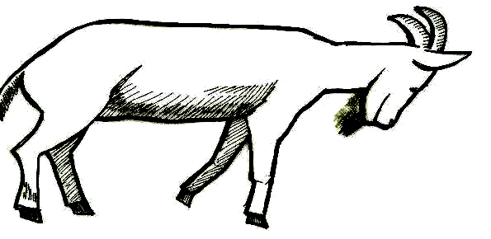

Read the story and answer the questions.
Try to write sentences if you can.

STORY:

Today is Mamie’s birthday. She is ten years old.

Mamie’s mother cooked rice, fufu, and soup for the party.

Mamie’s grandmother is coming to the party.

QUESTIONS:

- How old is Mamie?

____________________________________________________

- Who is coming to the party?

____________________________________________________

- Name one of the foods that Mamie’s mother cooked.

____________________________________________________
7.
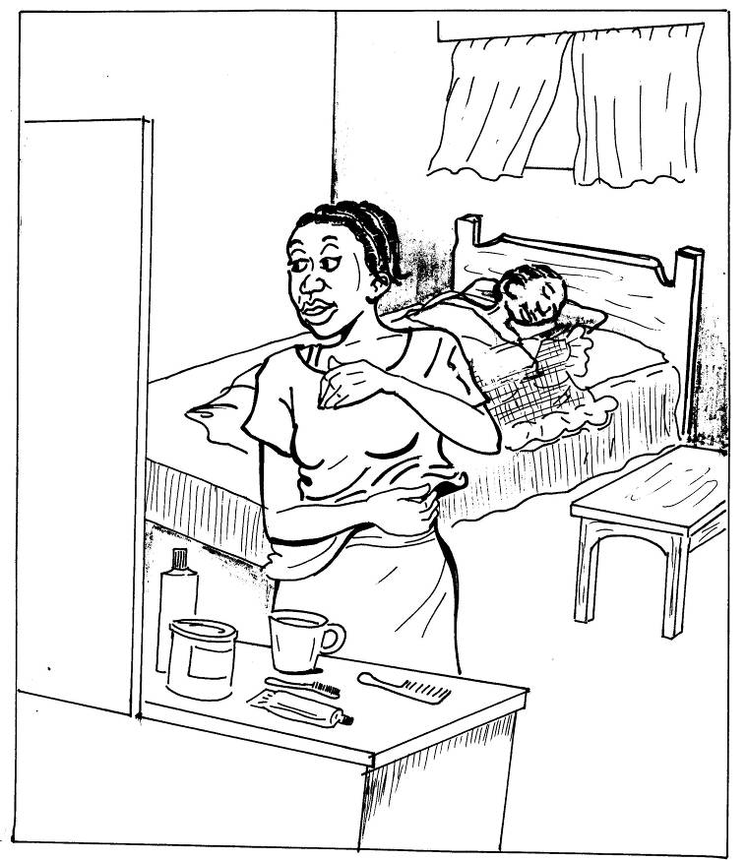

What do you see happening in this picture?
Describe at least 4 things in paragraph format.
Write your answers below:

_________________________________________________________________________

_________________________________________________________________________

_________________________________________________________________________

_________________________________________________________________________

_________________________________________________________________________

_________________________________________________________________________
Read the story and answer the questions.
Try to write sentences if you can.

“Fatu’s List”

Fatu was unhappy. She had a bad day. She was unable to fall asleep. She tossed and turned. She kept thinking of all the bad things that happened.

She could stand it no longer. Finally, she sat up. She found a piece of paper and a pen. She also got her flashlight. She said to herself, “I will write a list of all the things that happened today. Then the bad things will be on the paper, not in my head. I will be able to fall asleep.”

She wrote a long list. When she finished, her mind was finally free. She got back into bed and fell asleep.

QUESTIONS:

- What do we know about Fatu?

______________________________________________________________

_____________________________________________________________

- Do you think she is a careful person? Why or why not?

______________________________________________________________

______________________________________________________________

- What do you think of Fatu’s strategy? Is it a good idea? Why or why not?

______________________________________________________________

______________________________________________________________

Answer the math questions below.
Please show how you got your answers.
SHOW YOUR WORK!

ADDITION

11. 12.
3 5 3 8
+ 1 0 + 2 3

SUBTRACTION

13. 14.
9 7 7 1
- 2 2 - 4 6

MULTIPLICATION

15. 16.
1 3 2 3
X 2 X 4

DIVISION

17. 18.

5 40 4 27
Answer the questions below.
Please show how you got your answers.
SHOW YOUR WORK!

19.
Write the value of the money you see in the box. Show your work!

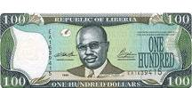

20.
Decontee bought 5 spoons for $15 LD each.

How much money did Decontee spend for the 5 spoons?

